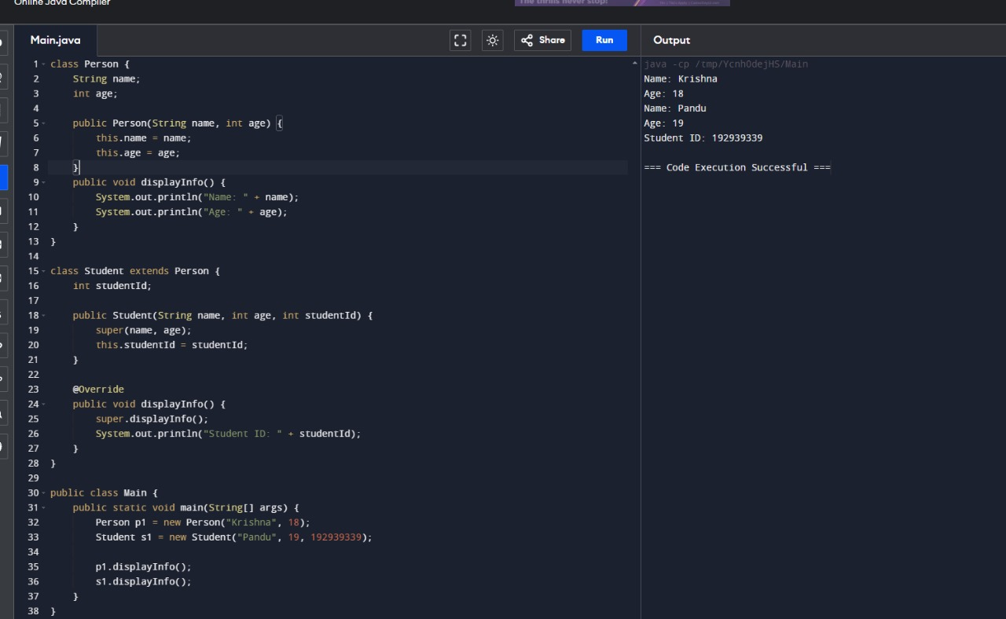

2. Create a class Vehicle with a method move(). Create subclasses Car and Bicycle, each

overriding the move() method to provide specific implementations. Demonstrate the use

of overridden methods.

